Simulation: Shock or Block

Title: AF w/ WPW vs VT

Learning Objectives:
- Overall management of the unstable cardiac arrhythmia
- Differentiate between SVT w/ Aberrancy and VT
- Demonstrate understanding of WPW and VT pathophysiology
- Display safe and effective Cardioversion management
- Be able to differentiate between sinus tachy., SVT w/ Aberrancy, VT
- Display understanding of the dangers of AV Nodal blockade in AF w/ WPW

Take Home Points:
- Age >30 has >85% specificity for VT
- Careful when blocking the AV node

Sim Brief - Introduction, Familiarisation, Ground Rules, Basic Assumption

Case Stem (for participants)
36 year old male presents to ED after LOC. Some seizure-like activity reported by girlfriend. Patient and girlfriend were out drinking all night. Approx. midnight patient fell to ground and there were some reported jerking of arms/legs. Regained consciousness. Occurred once more on the way into hospital. Presents having returned to consciousness but feels tired.

Background Info (For instructors eyes only)
- 36 yo male.
- PMHx: nil
- Soc Hx: Smoker. Social Drinker.
- Medications: nil

Settings for SIM Man/Woman
Bruise to head

Equipment required
- Cardiac monitor/Defib
- ECG printouts – AF w/ antidromic AVRT (WPW), sinus w/ WPW, VT as example
- VBG/ABG printouts – normal with slightly high lactate – 2 VBGs
- Imaging printouts – CXR – with oesophageal intubation. With endotracheal intubation
- O2 +/- masks/NP
- IVC equipment
- Relevant specific medications – adenosine, amiodarone
- Relevant products - colloids/crystalloids/blood

Participants required
- ED Registrars – Team Lead, Airway, Circ/Defib
- Nursing Staff – at least airway + drugs, ideally defib. and scribe

Scenario Outline
Brief outline in table form of step-by-step progression of SIM
Include possible alternatives and end-points

Scenario Outline  (Outline of what should occur at each stage) | Participant Response (Expected or ideal response) | Outcome (what do participants do, what happens to SIM mannequin)
Stem given to team | Role allocation. Plan of approach. | Team prepared and allocated prior to patient arriving
Patient arrives with Ambulance | Patient transferred over.  Handover given to team.  Begin to obtain a history | Patient responding and GCS 15/15 but feels lightheaded.
Assessment of patient | ABCDE approach  ED Reg. reviews charts  - HR thready pulse ?fast  - BP 100/82  - Sats 98% RA  - afebrile | A: Speaking  B: Clear, no creps/wheeze  C: Hypotensive. HR 250  - IV access ensured  - Bloods sent, ABG/VBG  D: GCS 15/15
Initial Treatment  Patient Stable | Notice:  - ECG  - Get 12 lead  - Pads on | - Team should make all arrangements to prepare for cardioversion if required  - Team should go through discussion of whether it is VT or AF w/ WPW
Pt. remains stable | - Pt. should be shocked.  - Obs to deteriorate if there is delay  - If patient is given adenosine, patient goes into VF | - If patient is shocked then patient stabilizes to sinus rhythm with WPW
Disposition Planning | - Cardiology  - ?Amiodarone | - End Sim

Debriefing Objectives:
- Cover technical areas
  - Differentiating between SVT w/ Aberrancy and VT
  - When not to give adenosine
- Relevant Non-Technical Skills.

Blood Gas 1

Sample (ABG/VBG) | Value | Reference Range
pH | 7.45 | 7.35 - 7.45
pCO2 | 30 | 35 - 45 mmHg
pO2 | 50 | 75 - 100 mmHg (arterial)
HCO3- | 23 | 22 - 26 mmol/L
Base Excess | 0 | -2 to +2 mmol/L
Hb | 130 | 135 - 180 g/L
Na+ | 140 | 135 - 145 mEq/L
K+ | 4.8 | 3.5 - 5.0 mEq/L
iCa2+ | 0.90 | 0.90 - 1.15 mmol/L
Cl- | 100 | 96 - 106 mmol/L
Anion Gap | 24 | 22 - 26
Lactate | 3 | 0.5 - 1.0 mmol/L
Bilirubin
Creatinine | 50 | 50 - 120 mmol/L

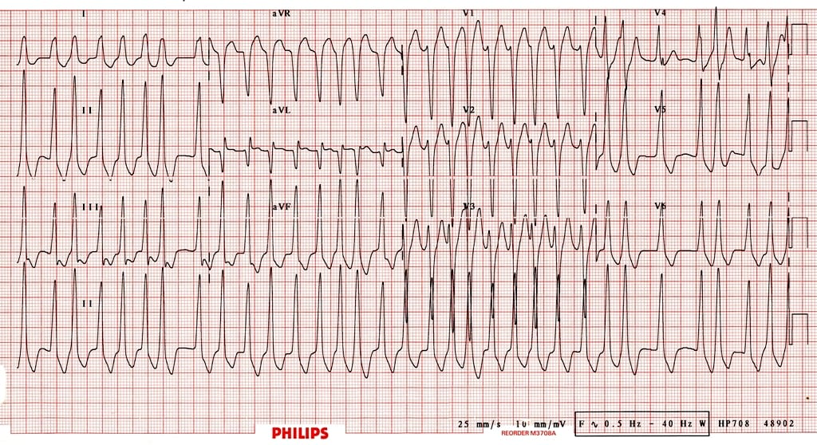

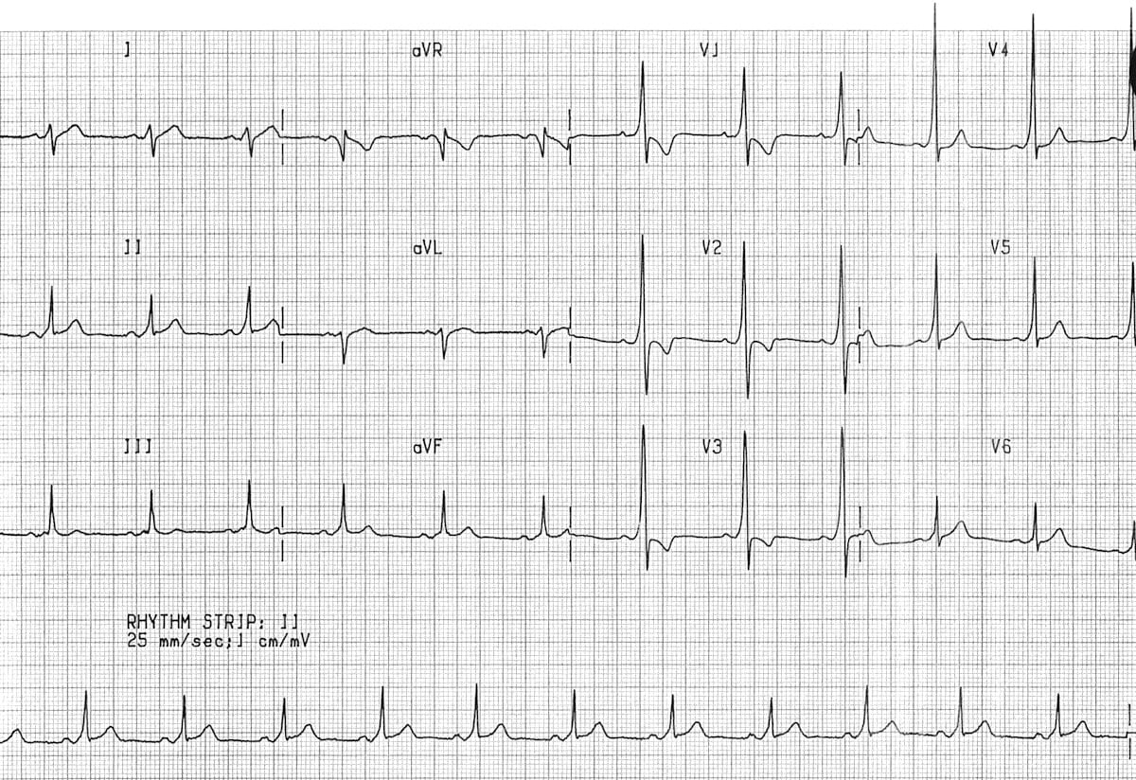

Non-Technical Skills
It is suggested to implement a consistent, frequent and repeated teaching of non-technical skills during SIM in order to entrain these skills.
The ANTS system is a suggested framework that can be applied for the observation of SIM.
See below for a brief screenshot of the framework, and a link to the ANTS handbook for further information.

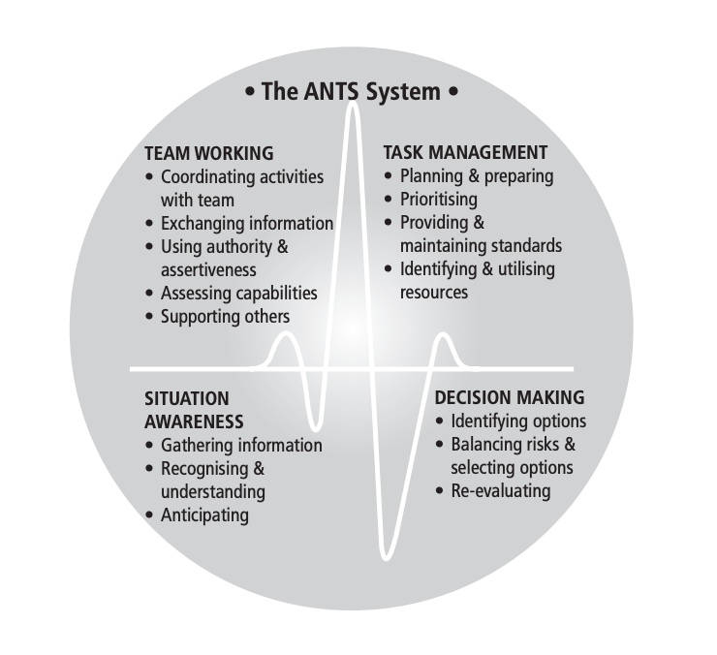
ANTS Framework
https://www.abdn.ac.uk/iprc/documents/ANTS%20Handbook%202012.pdf

