Simulation: Croup Resuscitation

Title: Its Bark is worse than its Bite.

Learning Objectives:
1. Diagnose and manage severe Croup
2. Recognise and stabilize paediatric respiratory distress
3. Demonstrate knowledge on intubating the unwell child
4. To effectively manage a team and demonstrate effective crisis resource management skills

Take Home Points:
- The importance of less is more with assessing/handling unwell children
- The importance of knowing where to find resources for treating the unwell child
- Importance of “insert relevant CRM skill here”

Sim Brief
Introduction, Familiarisation, Ground Rules, Basic Assumption

Case Stem (for participants) –

It’s 0100hrs. Consultant has left the ED. A mum runs into ED with her sick child who appears to have increased work of breathing. She heard that ramping was through the roof at PCH and brought her child to SCGH ED.

Background Info (For instructors eyes only)
12 month old.
PMHx: Full term SVD. Uncomplicated pregnancy and delivery. No significant maternal concerns.
Nil PMHx/PSHx/SHx. IUTD.
HPc: URTI Sx 2-4 days. Mild fever. Rhinorrhoea. Progressive cough (Barking). Progressed to Stridor in last 6-12 hours. Nil other sx. Normal wet nappies. No vomits. No concerning sx for meningitis.

Settings for SIM Man/Woman/Baby
No moulage.
HR 170, RR 42, BP 90/55. Sats 92% RA. T 37.8. Weight 10kg.

Equipment required
- Cardiac monitor/Defib – pt. will not arrest
- ECG printouts – Sinus tachycardia
- VBG/ABG printouts –
- Imaging printouts – CXR - croup
- O2 +/- masks/NP
- IVC equipment
- Relevant specific medications – propofol, roc, nebulized adrenaline, dexamethasone

Participants required
- ED Registrars 2-3
- ED Nurse – preferably 2 minimum (airway/drugs)
- Confederate – childs parent
- FACEM – 2nd debriefer/observer

Scenario Outline

Scenario Outline  (Outline of what should occur at each stage) | Participant Response (Expected or ideal response) | Outcome (what do participants do, what happens to SIM mannequin)
*pt. brought in by parent and nurse* | Doctors + Nurses attend patient and gain history  Nurses begin taking obs | Primary exam – stridor, nasal flaring, rib recession. No cyanosis.  Rest of exam normal
Assessment of patient | ABCDE approach  Reg. Notes vital signs  - T 37.8  - HR 170  - BP 90/55  - Sats 92% RA  - RR 42 | Start oxygen 100% via NRM – give to parent to hold close to childs face  Mask with nebulizer available
Initial management of patient | - Dexamethasone 0.6mg/kg IM/IV  - Nebulized Adrenaline 5mL 1:1000 (5mg) | - Allow for brief stabilization with treatment  - HR lowers, Sats improve
Ongoing management of patient | - Pt. begins to worsen clinically  - Increased stridor  - Increased RR -> decreased RR  - Sats low | - Progress to intubation
Progress to RSI | - RSI  - Preoxygenate – apnoeic o2  - Plan verbalised  - Optimise – vasopressors/inotropes/atropine ready  - Induction agent (propofol 2.5-3.5mg/kg decrease with age, ketamine 0.5 – 2mg/kg)  - Rocuronium 1.2-1.6mg/kg  - ETT 4-4.5 (age/4 + 4)  - Vt 6-8ml/kg | - Demonstrate safe RSI in an infant

Debriefing Objectives:
- Discuss management of severe croup including tips/tricks
- Discuss assessment of respiratory WOB in paediatric
- Discuss Paediatric RSI
- Discuss relevant Non-Technical Skills

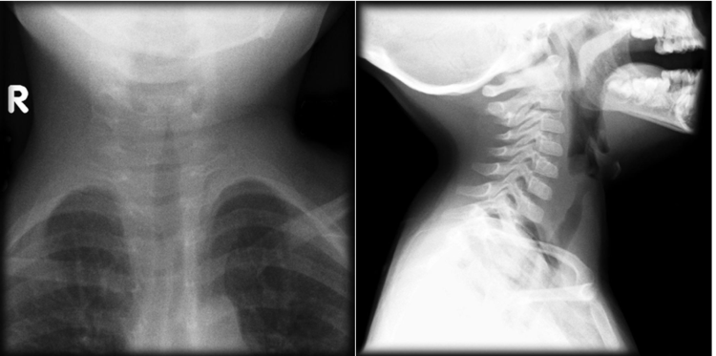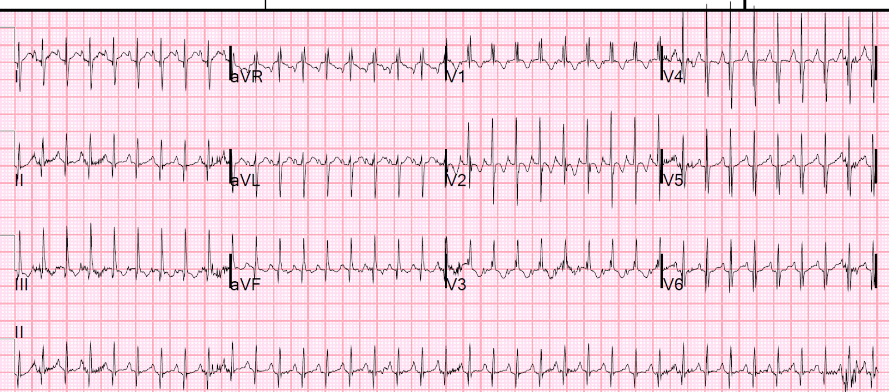

Non-Technical Skills

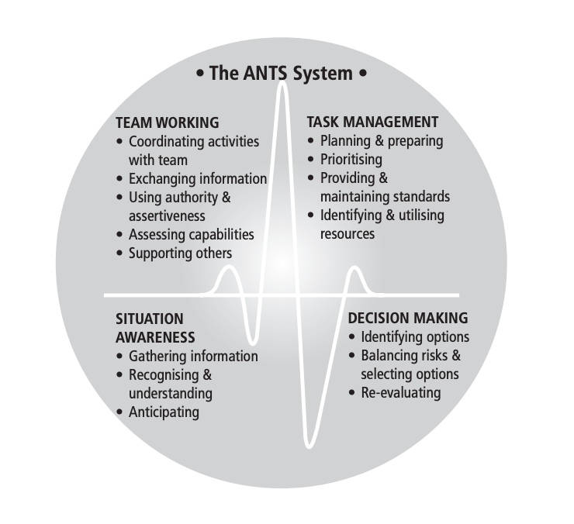
ANTS Framework
https://www.abdn.ac.uk/iprc/documents/ANTS%20Handbook%202012.pdf

