Simulation: Tox (Sotalol and TdP)

Title:

Learning Objectives: (enter - identify/demonstrate etc) - technical/non-technical
- Application of Toxicological approach (RRSIDEAD) to a resuscitation scenario
- Making an adequate Risk Assessment in a Toxicological resuscitation in the setting of Sotalol overdose
- Management of the patient with Torsades Des Pointes and specifically in preventing ongoing TdP in the poisoned patient
  - Correcting electrolyte disturbances
  - Giving Magnesium
  - Increasing HR to reduce Torsades Risk
- Display effective Non-Technical Skills in management of Toxicological Resuscitation

Take Home Points:
- The importance of risk assessment in managing a Toxicological resuscitation
- The importance of managing risk factors and predisposing factors in Toxicological resuscitation

Sim Brief - Introduction, Familiarisation, Ground Rules, Basic Assumption

Case Stem (for participants) – Read out to participant at the start. Brief case history. Typically ambulance handover style (MIST - Mechanism/Medical Complaint, Injuries/Illness, Signs & Symptoms, Treatment so far)
Mrs Betty Bloca, 80y.o lady being brought in by ambulance following an intentional overdose of her husbands Sotalol. Took 6x 80mg tablets of her husbands.

Background Info (For instructors eyes only)
- 80yo lady.
- PMHx: depression. Recently found out her husband was diagnosed with lung ca.
- Medications: Citalopram 20mg OD
- Ideal progression of Sim
  - Pt. wheeled in conscious but Brady, slightly hypotensive but can give some history.
  - Ideally history taken, establish amount of tablets taken and make a risk assessment. Include PMHx and recognise Citalopram is predisposing factor to TdP with coingestion of Sotalol
  - Investigate appropriately – ECG showing brady. + prolonged QT, VBG showing hypokalaemia and hypocalcaemia (recognise this increases risk)
  - Pt. is progressively bradycardic during this assessment
  - Eventually goes into Polymorphic VT arrest (TdP)
  - Team must go through appropriate ALS and treat with Magnesium SO4
  - Pt. eventually gets ROSC, but will continually go back into TdP until all predisposing factors are managed
    - Bradycardia addressed
    - Hypokalaemia addressed
    - Hypocalcaemia addressed
    - Continue to give Magnesium
    - Citalopram voiced as a risk factor
  - Continue in this way until risk factors managed or until no further progress
  - There should be appropriate call for help (Tox. On-call + Senior ED physician help +/- ICU)
  - Appropriate disposition planning

Settings for SIM Man/Woman
Significant moulage not required
Settings as per already on ALSi iPad – bradycardia, hypotension,

Equipment required
- Cardiac monitor/Defib
- ECG printouts – Prolonged QT, TdP, Bradycardia
- VBG/ABG printouts – hypokalaemia, hypocalcaemia – 2 VBGs
- Imaging printouts – CXR – normal. CXR with adequate intubation if required
- O2 +/- masks/NP
- IVC equipment
- Relevant specific medications – magnesium, roc/inhalers/nebulisers
- Relevant products - colloids/crystalloids/blood

Participants required
- ED Registrars – Team Lead, Airway, Circ/Defib
- Nursing Staff – at least airway + drugs, ideally defib. and scribe

Scenario Outline
Brief outline in table form of step-by-step progression of SIM
Include possible alternatives and end-points

Scenario Outline  (Outline of what should occur at each stage) | Participant Response (Expected or ideal response) | Outcome (what do participants do, what happens to SIM mannequin)
Stem given to team | Role allocation. Plan of approach.
Patient arrives with Ambulance | Patient transferred over.  Handover given to team.  Begin to obtain a history | Mannequin makes some groaning noises. Obs should begin to be taken.
Assessment of patient | ABCDE approach  ED Reg. reviews charts  - Notices vital signs  - Low BP  - Bradycardia  - RR 16  - GCS 14/15 | A: “feel terrible”  B: Clear  C: Bradycardic and hypotensive  - IV access ensured  - Bloods sent, ABG/VBG  D: GCS 14-15/15  E: nil relevant
Initial Treatment  Patient Deterioration | Notice:  - Sotalol and Citalopram both prolong QT  - ECG displays longQT  - HypoCa and HypoK on VBG  Begin to take steps to remedy this | - Ideally begin relevant corrections for abnormal values immediately and display recognition of TdP risk.  - Regardless, pt begins to progressively brady.  - Eventually, patient will go into TdP
Resus | - Pt. goes into TdP  - Team gives MgSO4  - Deliver shocks to patient adequately  - Begin to institute management of risk factors if not already done so (Correct K, Correct Ca)  - Overdrive pace | - Patient reverts back to sinus brady. With long QT  - Patient then goes back into Torsades
Ongoing Resus | - Patient continues to go in and out of TdP until all RFs are managed or no progress occurs  - Call for help (Tox – who gives advice) | - End Sim

Debriefing Objectives:
- Cover Toxicology of Sotalol OD
- Discuss Long QT if required
- What is TdP?
- Discuss what the management of TdP is.
- Relevant Non-Technical Skills.

Blood Gas 1

Sample (ABG/VBG) | Value | Reference Range
pH | 7.45 | 7.35 - 7.45
pCO2 | 30 | 35 - 45 mmHg
pO2 | 50 | 75 - 100 mmHg (arterial)
HCO3- | 24 | 22 - 26 mmol/L
Base Excess | 0 | -2 to +2 mmol/L
Hb | 120 | 135 - 180 g/L
Na+ | 140 | 135 - 145 mEq/L
K+ | 3.1 | 3.5 - 5.0 mEq/L
iCa2+ | 0.90 | 0.90 - 1.15 mmol/L
Cl- | 100 | 96 - 106 mmol/L
Anion Gap | 24 | 22 - 26
Lactate | 1.5 | 0.5 - 1.0 mmol/L
Bilirubin
Creatinine | 120 | 50 - 120 mmol/L

Blood Gas 2

Sample (ABG/VBG) | Value | Reference Range
pH | 7.45 | 7.35 - 7.45
pCO2 | 30 | 35 - 45 mmHg
pO2 | 50 | 75 - 100 mmHg (arterial)
HCO3- | 24 | 22 - 26 mmol/L
Base Excess | 0 | -2 to +2 mmol/L
Hb | 120 | 135 - 180 g/L
Na+ | 140 | 135 - 145 mEq/L
K+ | 2.9 | 3.5 - 5.0 mEq/L
iCa2+ | 0.90 | 0.90 - 1.15 mmol/L
Cl- | 100 | 96 - 106 mmol/L
Anion Gap | 24 | 22 - 26
Lactate | 1.8 | 0.5 - 1.0 mmol/L
Bilirubin
Creatinine | 120 | 50 - 120 mmol/L

Blood Gas 3

Sample (ABG/VBG) | Value | Reference Range
pH | 7.40 | 7.35 - 7.45
pCO2 | 40 | 35 - 45 mmHg
pO2 | 50 | 75 - 100 mmHg (arterial)
HCO3- | 24 | 22 - 26 mmol/L
Base Excess | 0 | -2 to +2 mmol/L
Hb | 120 | 135 - 180 g/L
Na+ | 143 | 135 - 145 mEq/L
K+ | 4.0 | 3.5 - 5.0 mEq/L
iCa2+ | 1.10 | 0.90 - 1.15 mmol/L
Cl- | 100 | 96 - 106 mmol/L
Anion Gap | 24 | 22 - 26
Lactate | 1.5 | 0.5 - 1.0 mmol/L
Bilirubin
Creatinine | 120 | 50 - 120 mmol/L

Include Imaging/ECG here:
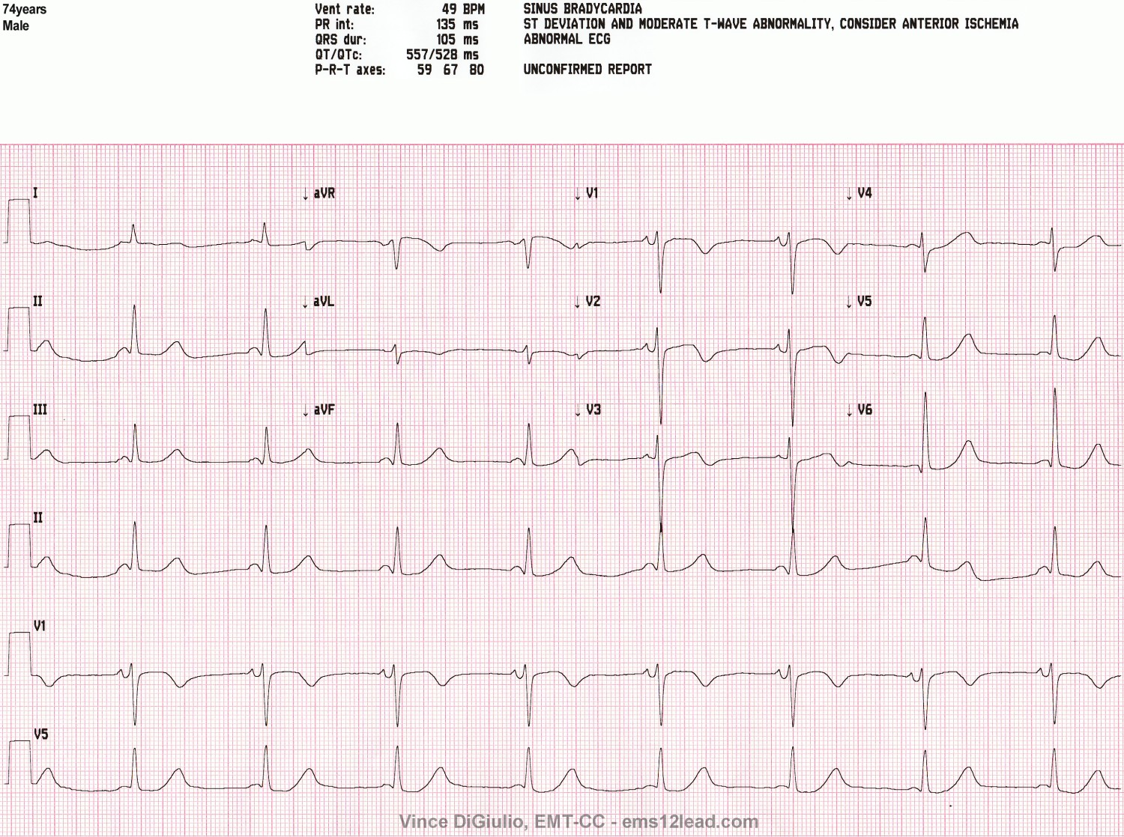

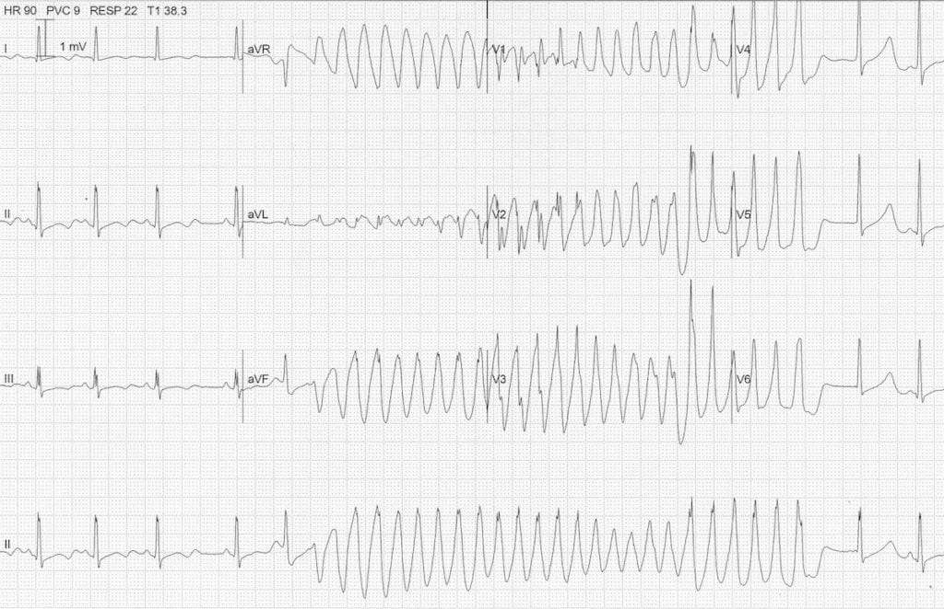

Non-Technical Skills
It is suggested to implement a consistent, frequent and repeated teaching of non-technical skills during SIM in order to entrain these skills.
The anaesthesia is a suggested framework that can be applied for the observation of SIM.
See below for a brief screenshot of the framework, and a link to the ANTS handbook for further information.
Feel free to choose your own approach here.

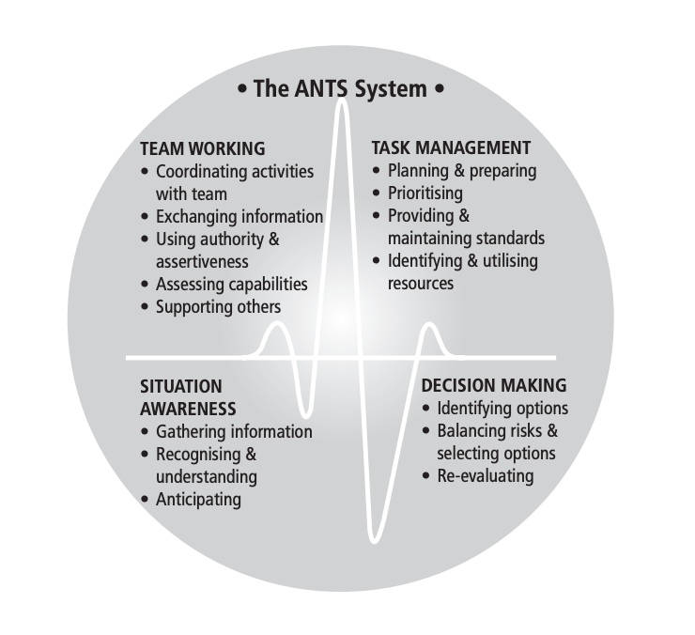
ANTS Framework
https://www.abdn.ac.uk/iprc/documents/ANTS%20Handbook%202012.pdf

