Simulation: COPD

Title:

Learning Objectives: (enter - identify/demonstrate etc) - technical/non-technical
- Diagnose and treat severe COPD exacerbation in the ED setting
- Demonstrate appropriate use of NIV in setting of Type 2 respiratory failure (indications, contraindications, titration etc)
- Demonstrate ability to troubleshoot clinical deterioration in the setting of severe COPD with NIV
- Demonstrate save Intercostal Catheter Insertion in an emergency situation

Sim Brief - Introduction, Familiarisation, Ground Rules, Basic Assumption

Case Stem (for participants) – Read out to participant at the start. Brief case history. Typically ambulance handover style (MIST - Mechanism/Medical Complaint, Injuries/Illness, Signs & Symptoms, Treatment so far)
66 year old male.
Brought to resus by paramedics. 2 day history of cough and increasing shortness of breath.
Febrile this morning and wife noted him to be confused.

PMHx:
- COPD
- Hypertension
- Hypercholesterolaemia
- Smoker

Medications:
- Salbutamol inhaler
- Amlodipine
- Atorvastatin

Background Info (For instructors eyes only)
- 66 year old man
- Ideal progression of Sim
  - Pt. wheeled in conscious with significant increased work of breathing and mildly confused.
  - Ideally history taken at handover
  - Appropriate investigation, diagnosis and management of severe COPD
  - Appropriate application of BiPAP
  - Troubleshooting of BiPAP
  - Timely insertion of chest drain
  - Appropriate disposition planning

Settings for SIM Man/Woman
Significant moulage not required
Settings as per already on ALSi iPad

Equipment required
- Cardiac monitor/Defib
- ECG printouts – tachycardia
- VBG/ABG printouts – low/normal pH – 2 VBGs/ABGs
- Imaging printouts – CXR – pneumonia and emphysematous changes
- O2 +/- masks/NP
- IVC equipment
- Bipap/CPAP
- Chest tube
- Relevant specific medications – ventolin, atrovent
- Relevant products - colloids/crystalloids/blood

Participants required
- ED Registrars – Team Lead, Airway, Circ/Defib
- Nursing Staff – at least airway + drugs, ideally defib. and scribe

Scenario Outline
Brief outline in table form of step-by-step progression of SIM
Include possible alternatives and end-points

Scenario Outline  (Outline of what should occur at each stage) | Participant Response (Expected or ideal response) | Outcome (what do participants do, what happens to SIM mannequin)
Stem given to team | Role allocation. Plan of approach.
Patient arrives with Ambulance | Patient transferred over.  Handover given to team.  Begin to obtain a history | Mannequin has significantly increased WOB. Appears confused. Obs should begin to be taken.
Assessment of patient | ABCDE approach  ED Reg. reviews charts  - Notices vital signs  - BP 128/90  - 130  - RR 35  - GCS 14/15  - Sats 75% | A: Mumbles, confused words  B: hyperventilating. Creps left base.  C: Tachycardia and normotensive  - IV access ensured  - Bloods sent, ABG/VBG  D: GCS 14-15/15  E: nil relevant
Initial Treatment  Patient Deterioration | Notice:  - ABG/VBG hypercarbia type 2 respiratory failure  - Low saturations  Begin to take steps to remedy this | - Appropriate inhaler/nebuliser therapy  - Appropriate antibiotic choice  - Appropriate oxygen therapy and considerations regarding this (CO2 retainer, saturation targets)
Resus | - Patient deteriorates despite adequate therapy  - Decision for NIV | - Team should display appropriate application of NIV
Ongoing Resus | - Pt has appropriate Bipap application with appropriate IPAP/EPAP pressures applied  - Soon after this, pt. has increasing respiratory distress and drop in saturations | - Team to display appropriate troubleshooting of low oxygen saturations  - Determine pneumothorax secondary to NIV  - Act quickly to place chest tube
Stabilization | - Patient stabilizes once chest tube in  - Continue with COPD therapy | - Disposition planning  - ICU and Respiratory

Debriefing Objectives:
- Management of COPD exacerbation
  - Nebs/inhalers
  - Antibiotics
- Non-invasive ventilation in the setting of COPD exacerbation
- ABG/VBG interpretation
- Troubleshooting in COPD exacerbation
- Relevant Non-Technical Skills.

Blood Gas 1

Sample (ABG/VBG) | Value | Reference Range
pH | 7.32 | 7.35 - 7.45
pCO2 | 65 | 35 - 45 mmHg
pO2 | 50 | 75 - 100 mmHg
HCO3- | 21 | 22 - 26 mmol/L
Base Excess | 0 | -2 to +2 mmol/L
Hb | 120 | 135 - 180 g/L
Na+ | 140 | 135 - 145 mEq/L
K+ | 3.5 | 3.5 - 5.0 mEq/L
iCa2+ | 0.90 | 0.90 - 1.15 mmol/L
Cl- | 100 | 96 - 106 mmol/L
Anion Gap | 24 | 22 - 26
Lactate | 3 | 0.5 - 1.0 mmol/L
Bilirubin
Creatinine | 120 | 50 - 120 mmol/L

Blood Gas 2

Sample (ABG/VBG) | Value | Reference Range
pH | 7.29 | 7.35 - 7.45
pCO2 | 78 | 35 - 45 mmHg
pO2 | 50 | 75 - 100 mmHg
HCO3- | 28 | 22 - 26 mmol/L
Base Excess | 0 | -2 to +2 mmol/L
Hb | 120 | 135 - 180 g/L
Na+ | 140 | 135 - 145 mEq/L
K+ | 3.6 | 3.5 - 5.0 mEq/L
iCa2+ | 0.90 | 0.90 - 1.15 mmol/L
Cl- | 100 | 96 - 106 mmol/L
Anion Gap | 26 | 22 - 26
Lactate | 4 | 0.5 - 1.0 mmol/L
Bilirubin
Creatinine | 120 | 50 - 120 mmol/L

Blood Gas 3

Sample (ABG/VBG) | Value | Reference Range
pH | 7.35 | 7.35 - 7.45
pCO2 | 56 | 35 - 45 mmHg
pO2 | 50 | 75 - 100 mmHg
HCO3- | 20 | 22 - 26 mmol/L
Base Excess | 0 | -2 to +2 mmol/L
Hb | 120 | 135 - 180 g/L
Na+ | 143 | 135 - 145 mEq/L
K+ | 4.0 | 3.5 - 5.0 mEq/L
iCa2+ | 1.10 | 0.90 - 1.15 mmol/L
Cl- | 100 | 96 - 106 mmol/L
Anion Gap | 24 | 22 - 26
Lactate | 1.5 | 0.5 - 1.0 mmol/L
Bilirubin
Creatinine | 120 | 50 - 120 mmol/L

CXR 1

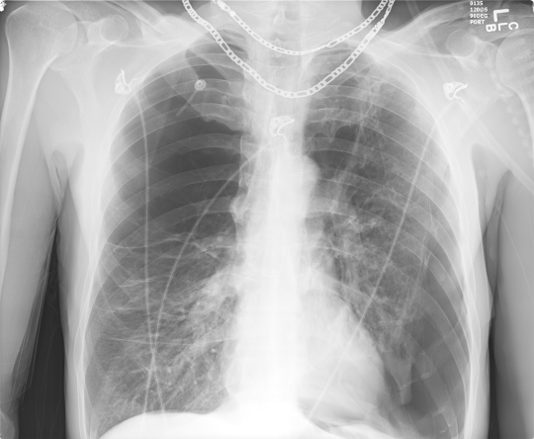

CXR 2

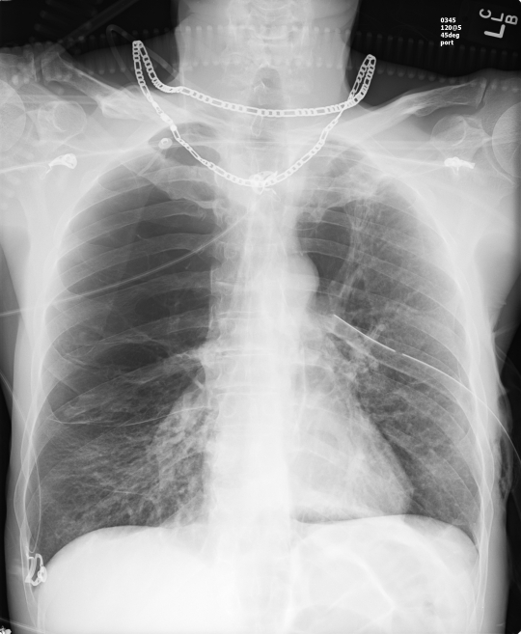

Non-Technical Skills
It is suggested to implement a consistent, frequent and repeated teaching of non-technical skills during SIM in order to entrain these skills.
The anaesthesia is a suggested framework that can be applied for the observation of SIM.
See below for a brief screenshot of the framework, and a link to the ANTS handbook for further information.
Feel free to choose your own approach here.

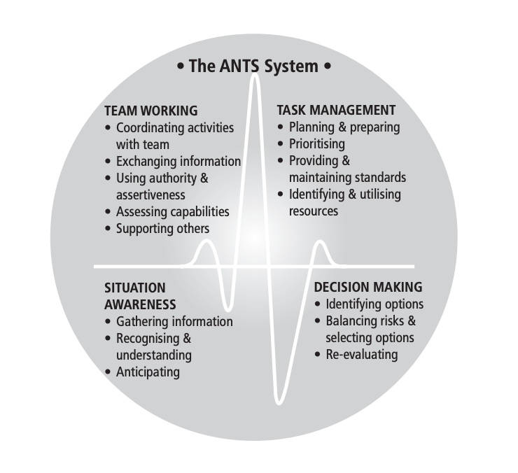
ANTS Framework
https://www.abdn.ac.uk/iprc/documents/ANTS%20Handbook%202012.pdf

