Simulation: Tox (TCA)

Title:

Learning Objectives: (enter - identify/demonstrate etc) - technical/non-technical
- Application of Toxicological approach (RRSIDEAD) to a resuscitation scenario
- Making an adequate Risk Assessment in a Toxicological resuscitation in the setting of TCA (Dothiepin) overdose
- Management of the patient with seizures/coma and cardiac toxicity in the TCA overdose patient
  - Bicarbonate administration
  - Intubation and hyperventilation to manage symptoms – pH 7.50-7.55
  - Management of seizures with benzodiazepines
- Display effective Non-Technical Skills in management of Toxicological Resuscitation

Take Home Points:
- The importance of Risk Assessment in management of TCA overdose (>10mg/kg potentially life threatening)
- The importance of Sodium Bicarbonate administration and hyperventilation for prevention of cardiac toxicity in TCA overdose

Sim Brief - Introduction, Familiarisation, Ground Rules, Basic Assumption

Case Stem (for participants) – Read out to participant at the start. Brief case history. Typically ambulance handover style (MIST - Mechanism/Medical Complaint, Injuries/Illness, Signs & Symptoms, Treatment so far)
Pt. is 22yo Shenealle-Grey PeachFlower.
Called Ambulance after taking overdose of her medication following an argument with her boyfriend. 60kg pt.

Time of ingestion: 1hr prior
Dothiepin 75mg x 15 (15 left in pack) = 1125mg
Diazepam 5mg x 10 (40 left in pack) = 50mg
ETOH – mixed. BAL 0.03

PMHx:
Borderline PD
Past Suicide attempts

Medications:
Dothiepin 75mg OD
Temazepam 10mg nocte prn
Diazepam 5mg PRN for anxiety

Background Info (For instructors eyes only)
- 22yo lady.
- Ideal progression of Sim
  - Pt. wheeled in conscious but drowsy, slightly hypotensive but can give some history.
  - Ideally history taken, establish amount of tablets taken and make a risk assessment. Include PMHx and recognise life threatening dose is predisposing of Dothiepin (TCA)
  - Identify need for RSI, Intubation and Hyperventilation
  - Appropriate investigation – VBG, ECG, Paracetamol etc
  - Appropriate seizure management
  - Appropriate cardiotoxicity management
    - Repeat doses of Bicarb. 2mmol/kg 1-2minutely until resolution
  - There should be appropriate call for help (Tox. On-call + Senior ED physician help +/- ICU)
  - Appropriate disposition planning

Settings for SIM Man/Woman
Significant moulage not required
Settings as per already on ALSi iPad – tachycardia, normotension,

Equipment required
- Cardiac monitor/Defib
- ECG printouts – Prolonged QT, TdP, Bradycardia
- VBG/ABG printouts – low/normal pH – 2 VBGs
- Imaging printouts – CXR – normal. CXR with adequate intubation if required
- O2 +/- masks/NP
- IVC equipment
- Relevant specific medications - bicarbonate
- Relevant products - colloids/crystalloids/blood

Participants required
- ED Registrars – Team Lead, Airway, Circ/Defib
- Nursing Staff – at least airway + drugs, ideally defib. and scribe

Scenario Outline
Brief outline in table form of step-by-step progression of SIM
Include possible alternatives and end-points

Scenario Outline  (Outline of what should occur at each stage) | Participant Response (Expected or ideal response) | Outcome (what do participants do, what happens to SIM mannequin)
Stem given to team | Role allocation. Plan of approach.
Patient arrives with Ambulance | Patient transferred over.  Handover given to team.  Begin to obtain a history | Mannequin makes some groaning noises and confused mumblings. Obs should begin to be taken.
Assessment of patient | ABCDE approach  ED Reg. reviews charts  - Notices vital signs  - Low BP  - Tachycardia  - RR 16  - GCS 14/15 | A: Mumbles, confused words  B: Clear  C: Tachycardia and hypotensive  - IV access ensured  - Bloods sent, ABG/VBG  D: GCS 14-15/15  E: nil relevant
Initial Treatment  Patient Deterioration | Notice:  - ECG displays widened QRS  - pH low-normal  Begin to take steps to remedy this | - Ideally begin relevant corrections for abnormal values immediately and display recognition of TCA OD risk.  - Take step towards RSI  - If inadequate progress, patient will have a seizure
Resus | - Pt. has seizure  - Display appropriate seizure management  - Will cease with benzodiazepines  - Sats will drop until some airway maneouvres | - Team should progress to intubation
Ongoing Resus | - Pt. is intubated  - Unless appropriate bicarbonate administration pt. will develop widening QRS  - Pt. goes into VT unresponsive to defibrillation  - Pt. will respond only if adequate bicarb. Given to pH target, and hyperventilated | - End Sim

Debriefing Objectives:
- Cover Toxicology of TCA OD
  - SNRI, GABA-antagonist, antimuscarinic, antihistamine, peripheral alpha receptor blockers
  - 10mg/kg and greater is potentially lethal
  - Peak 1-2 hours
  - Large Vd – plasma and tissue protein bound
- Discuss concept of bicarbonate administration
  - Improved fast sodium channel function mitigates na-ch blocker effect
  - Maximal at 7.50-7.55
  - 50ml 8.4% NaHCO3 = 50mmol
  - 2mmol/kg (120mmol) every 1-2 minutes
  - Infusion = 150mmol in 850ml N/Saline at 250ml/hr
- ECG in TCA
  - NaCh blockade. QRS >100 = seizures. >160 = arrhythmias.
  - R wave >3mm aVR. Widened QRS.
- Relevant Non-Technical Skills.

Blood Gas 1

Sample (ABG/VBG) | Value | Reference Range
pH | 7.30 | 7.35 - 7.45
pCO2 | 48 | 35 - 45 mmHg
pO2 | 50 | 75 - 100 mmHg (arterial)
HCO3- | 21 | 22 - 26 mmol/L
Base Excess | 0 | -2 to +2 mmol/L
Hb | 120 | 135 - 180 g/L
Na+ | 140 | 135 - 145 mEq/L
K+ | 3.5 | 3.5 - 5.0 mEq/L
iCa2+ | 0.90 | 0.90 - 1.15 mmol/L
Cl- | 100 | 96 - 106 mmol/L
Anion Gap | 24 | 22 - 26
Lactate | 1.5 | 0.5 - 1.0 mmol/L
Bilirubin
Creatinine | 120 | 50 - 120 mmol/L

Blood Gas 2 (hyperventilation and bicarb)

Sample (ABG/VBG) | Value | Reference Range
pH | 7.45 | 7.35 - 7.45
pCO2 | 30 | 35 - 45 mmHg
pO2 | 50 | 75 - 100 mmHg (arterial)
HCO3- | 28 | 22 - 26 mmol/L
Base Excess | 0 | -2 to +2 mmol/L
Hb | 120 | 135 - 180 g/L
Na+ | 140 | 135 - 145 mEq/L
K+ | 3.6 | 3.5 - 5.0 mEq/L
iCa2+ | 0.90 | 0.90 - 1.15 mmol/L
Cl- | 100 | 96 - 106 mmol/L
Anion Gap | 24 | 22 - 26
Lactate | 1.8 | 0.5 - 1.0 mmol/L
Bilirubin
Creatinine | 120 | 50 - 120 mmol/L

Blood Gas 3

Sample (ABG/VBG) | Value | Reference Range
pH | 7.55 | 7.35 - 7.45
pCO2 | 29 | 35 - 45 mmHg
pO2 | 50 | 75 - 100 mmHg (arterial)
HCO3- | 24 | 22 - 26 mmol/L
Base Excess | 0 | -2 to +2 mmol/L
Hb | 120 | 135 - 180 g/L
Na+ | 143 | 135 - 145 mEq/L
K+ | 4.0 | 3.5 - 5.0 mEq/L
iCa2+ | 1.10 | 0.90 - 1.15 mmol/L
Cl- | 100 | 96 - 106 mmol/L
Anion Gap | 24 | 22 - 26
Lactate | 1.5 | 0.5 - 1.0 mmol/L
Bilirubin
Creatinine | 120 | 50 - 120 mmol/L

ECG 1
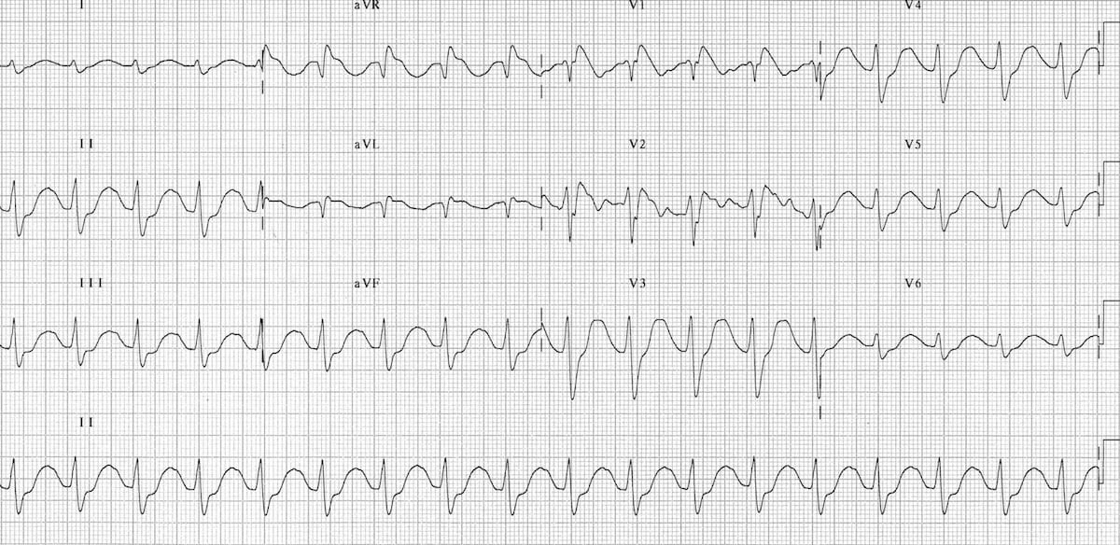

ECG 2
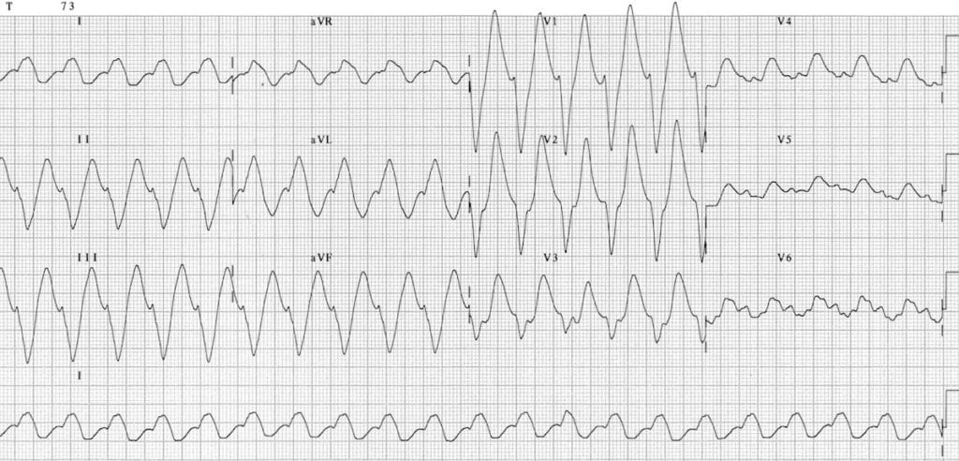

ECG 3

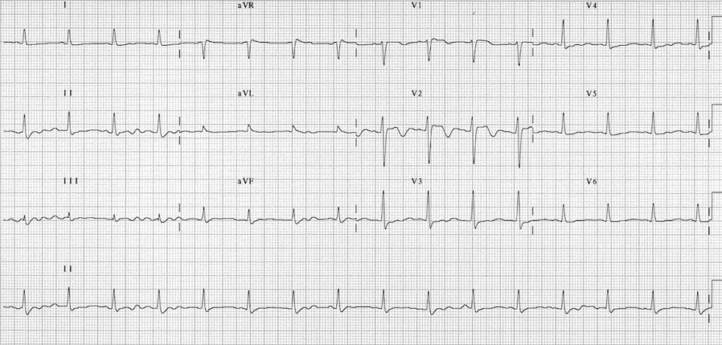

Non-Technical Skills
It is suggested to implement a consistent, frequent and repeated teaching of non-technical skills during SIM in order to entrain these skills.
The anaesthesia is a suggested framework that can be applied for the observation of SIM.
See below for a brief screenshot of the framework, and a link to the ANTS handbook for further information.
Feel free to choose your own approach here.

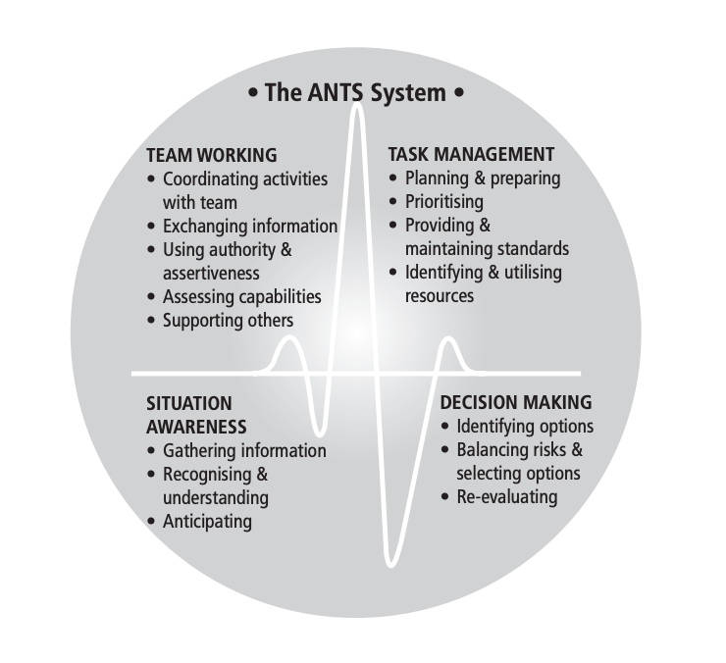
ANTS Framework
https://www.abdn.ac.uk/iprc/documents/ANTS%20Handbook%202012.pdf

